**Objective Questions**

1. **In analyzing the hospital dataset with Power BI, ensure data cleaning to address inconsistencies and missing values before further analysis.**

Date-Time Handling:

* Split the date column into separate visit_date and visit_time columns.
* Converted visit_date to proper Date format and visit_time to Time format.

Missing Values (Nulls):

patient_sat_score had missing values. These were imputed with the average satisfaction score (e.g., 5), using conditional replacement logic to avoid data loss.

Data Types Correction:

* Columns like patient_age, patient_waittime, and patient_sat_score were converted to appropriate numeric types.
* patient_admin_flag was converted to Boolean.
* Text fields like patient_race and Doctor Name were formatted and trimmed to remove unwanted spaces.

Duplicate Handling:

* Checked and removed duplicate patient IDs with identical records using Power Query.

Created Column:

* Year column (New Column)

Year = YEAR('Hospital ER '[visit_date])

### Table Merge (Join)

### Merged the Hospital ER CSV data with the Doctor_Patients_data Excel table using patient_id to analyze patient visits along with billing and doctor info.

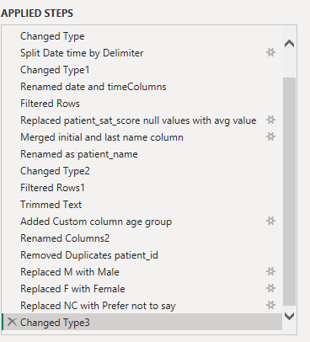

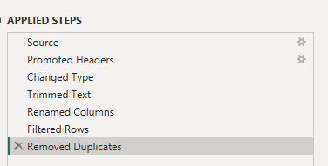

1. **Assess the Average Waiting Time: Analyse the patient wait times to identify the average duration a patient spends before receiving care.**

Avg_Wait_Time = AVERAGE('Hospital ER '[patient_waittime])

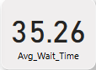

1. **Visits by Department Referral: Calculate the total number of visits to each department based on referrals to understand which departments are most frequently visited.**

Department_Visit_Count = COUNT('Hospital ER '[patient_id])

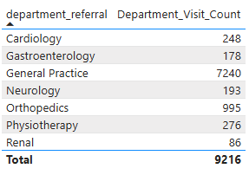

1. **Patient Visits by Age Group: Segregate patient visits according to different age groups to see which demographics utilize healthcare services the most.**

Age group (Custom Column)

= if [patient_age] <= 10 then "0-10"

else if [patient_age] <= 20 then "11-20"

else if [patient_age] <= 30 then "21-30"

else if [patient_age] <= 40 then "31-40"

else if [patient_age] <= 50 then "41-50"

else if [patient_age] <= 60 then "51-60"

else "60+"

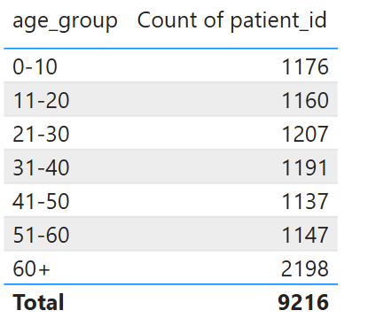

Age Group =

SWITCH(

TRUE(),

'Hospital ER '[patient_age] < 13, "Child",

'Hospital ER '[patient_age] >= 13 && 'Hospital ER '[patient_age] < 20, "Teenage",

'Hospital ER '[patient_age] >= 20 && 'Hospital ER '[patient_age] < 40, "Young Adult",

'Hospital ER '[patient_age] >= 40 && 'Hospital ER '[patient_age] < 65, "Middle-Aged",

'Hospital ER '[patient_age] >= 65, "Senior",

"Unknown"

)

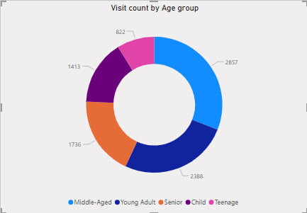

1. **Were there any Null values in the data? What would be the best way to handle these Null values and which approach have you opted for?**

### Handling Null Values in the Data

Presence of Null Values:  
 The dataset contained null (missing) values in the Patient Satisfaction Score (patient_sat_score) and occasionally in other fields.

Best Practices for Handling Nulls:

* Identify and understand the context of nulls (e.g., is missing data meaningful or an error?).
* For numerical fields like satisfaction scores, common approaches include:
  + Imputing with mean or median values.
  + Using a default or placeholder value if appropriate.
  + Removing rows with nulls if their number is small and won’t bias results.
* For categorical fields, replacing nulls with "Unknown" or most frequent category is typical.
* Always document the approach taken to ensure transparency.

Approach Used in This Analysis:

* For Patient Satisfaction Score, null values were replaced with the average satisfaction score of the dataset to maintain data consistency.

1. **Is there any relation between the number of visits and the Gender of the patients?**

Visited_by_gender = COUNT('Hospital ER '[patient_id])

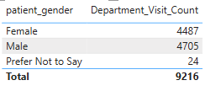

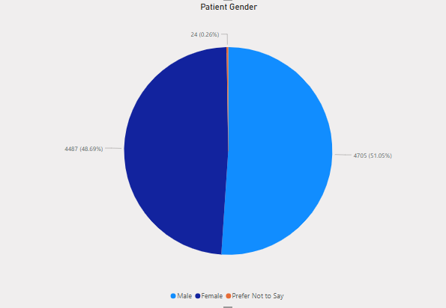

### Gender-wise Patient Visit Analysis

Visit Counts:

* Female: 4,887 visits ( 53.0% of total)
* Male: 4,705 visits ( 51.0% of total)
* Prefer not to say: 24 visits ( 0.3% of total)
* Total: 9,216 visits

### **Insights:**

1. Slight Female Majority  
    Female patients account for a marginally higher percentage of total hospital visits compared to males. This could be due to:  
   * More frequent preventive checkups.
   * Higher health awareness or health-seeking behavior among females.
2. Gender Balance Overall  
    The gender split is relatively balanced (~53% Female vs. ~51% Male), suggesting the hospital offers services that cater evenly to both genders.
3. Very Low Non-disclosure  
    Only 0.3% of patients chose not to disclose their gender, indicating:  
   * Most patients are comfortable sharing personal information.
   * Data reliability is high for gender-based analytics.

### **Recommendation:**

The hospital should continue maintaining gender-inclusive healthcare services. Additionally, exploring department-wise or age-wise gender visit patterns could further uncover specialized healthcare needs by gender.

1. **Average Satisfaction by Demographics: Determine the relationship between patient satisfaction scores, their age groups, and racial backgrounds to pinpoint areas for improvement in patient experience.**

Avg_Satisfaction = AVERAGE('Hospital ER '[patient_sat_score])

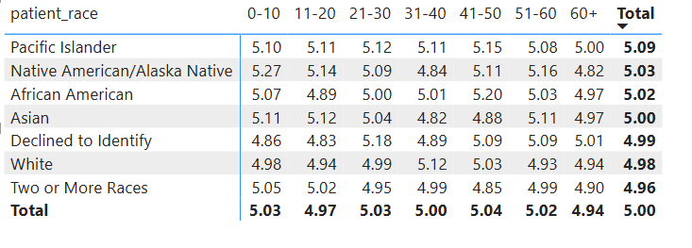

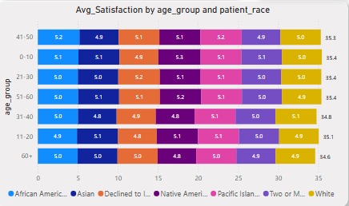

**Insights :**

Highest Satisfaction:

* Pacific Islanders show relatively high satisfaction (~5.09) across all age groups.
* Native American/Alaska Native patients under age 10 report the highest score (5.27).

Lowest Satisfaction:

* Asian patients aged 31–40 (4.82) and Two or More Races aged 41–50 (4.85) have the lowest scores.
* White patients have consistently low scores (~4.93–5.12), especially in older age brackets.

Teen and Senior Gaps:

* Several races (e.g., African American, Declined to Identify, White) show slightly lower satisfaction among seniors (60+), averaging below 5.00.
* Teenagers (11–20) show dips in satisfaction for African American and Asian patients.

### **Recommendations:**

1. Targeted Feedback Programs:  
   * Conduct deeper surveys for Asian and White patients aged 31–60 to understand dissatisfaction drivers.
   * Introduce patient education, multilingual communication, or culturally aware care staff in departments serving these groups.
2. Age-Specific Engagement:  
   * Improve teen experience (age 11–20), especially among African American and Asian patients. Consider youth-friendly environments or communication.
3. Senior Outreach:  
   * Since most races show a satisfaction dip in the 60+ group, train staff in geriatric care sensitivity and comfort-focused service.
4. **The hospital's managing director seeks to evaluate the revenue of each department to understand how much revenue is generated by each.**

Total_Revenue = SUM('Doctor_Patients_data'[Total_Bill])

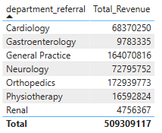

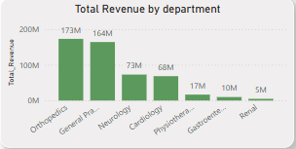

### **Insights:**

#### Top-Performing Departments (by Revenue):

1. Orthopedics: ₹17.29 Cr — Highest contributor (≈34% of total revenue)
2. General Practice: ₹16.40 Cr — High-volume department
3. Neurology: ₹7.28 Cr — Despite lower volume, strong revenue (possibly due to high treatment costs)

#### Low Revenue Contributors:

* Renal: ₹0.47 Cr — Least revenue; consider evaluating cost-efficiency or demand
* Gastroenterology: ₹0.98 Cr
* Physiotherapy: ₹1.66 Cr

### **Recommendations :**

#### 1. Scale High Revenue Departments Strategically

* Orthopedics and General Practice together contribute over 65% of the total revenue.
* Action:  
  + Hire more staff (especially doctors) in these departments to reduce wait time and manage patient load.
  + Expand services or introduce specialty care packages (e.g., ortho-rehab combos).

#### 2. Improve Operational Efficiency in Mid-Tier Revenue Departments

* Neurology and Cardiology contribute significantly (₹7–₹6 Cr).
* Action:  
  + These departments likely deal with complex, high-cost treatments—optimize consultation-to-treatment conversion rates.
  + Analyze satisfaction scores and streamline diagnostics for faster throughput.

#### 3. Reassess or Reposition Low Revenue Departments

* Renal, Physiotherapy, and Gastroenterology contribute <5% of revenue combined.
* Action:  
  + Conduct cost-benefit analysis: Are these departments essential for comprehensive care or are they underutilized?
  + Introduce cross-referrals from General Practice to these units.
  + Offer packages or promote preventive care (e.g., renal check-up plans).

#### 4. Design Revenue-Specific Promotions

* Promote check-up or wellness packages in General Practice to maintain patient loyalty.
* Bundle Orthopedic & Physiotherapy care to improve post-surgical recovery and revenue.

#### 5. Monitor Margins, Not Just Revenue

* Some high-revenue departments may also have high costs (Neurology/Cardiology).
* Action: Integrate cost data to analyze net profitability and avoid misleading revenue-heavy but loss-making units.

1. **Which department is charging the highest appointment fees in general? Use an aggregation DAX function to solve this question.**

Max_Appointment_Fee_Department =

CALCULATE(MAXX(

VALUES('Doctor_Patients_data'[department_referral]),

CALCULATE(AVERAGE('Doctor_Patients_data'[Appointment_Fees]))))

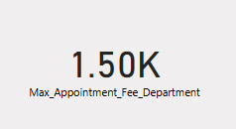

1. **Create a tabular visualization in the Report view which consists of Month-wise total visits in the hospital. Add a third column in the table that consists of the previous month’s total visits for each month’s row. Also, include a column that states whether the visits in a month are greater than that of the previous month's visits.**

Month = FORMAT('Hospital ER '[visit_date].[Date], "MMMM")

Previous_Month_Visits =

VAR CurrentMonth = MONTH(MAX('Hospital ER '[visit_date]))

VAR CurrentYear = YEAR(MAX('Hospital ER '[visit_date]))

VAR PrevMonth = IF(CurrentMonth = 1, 12, CurrentMonth - 1)

VAR PrevYear = IF(CurrentMonth = 1, CurrentYear - 1, CurrentYear)

RETURN

CALCULATE(

COUNT('Hospital ER '[patient_id]),

FILTER(

ALL('Hospital ER '),

MONTH('Hospital ER '[visit_date]) = PrevMonth &&

YEAR('Hospital ER '[visit_date]) = PrevYear))

Visits_Increased =

IF(

[Visit_Count] > [Previous_Month_Visits],

"Increased",

"Decreased")

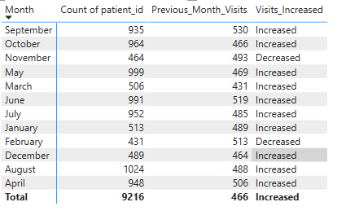

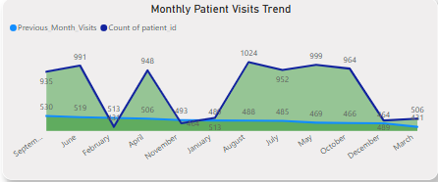

1. **Using ‘Calculate’ and a row iteration DAX function calculate the total number of patients who have visited Dr. Smith.**

DrSmith_Patient_Count =

CALCULATE(

COUNTROWS('Doctor_Patients_data'),

FILTER(

'Doctor_Patients_data',

'Doctor_Patients_data'[Doctor_Name] = "Dr. Smith"))

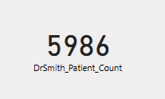

1. **Calculate the average age of the patients who visit the Orthopedics department. Will the approach used to calculate this metric be different if the requirement had been all departments’ average age?**

Avg_Age_Orthopedics =

CALCULATE(

AVERAGE('Hospital ER '[patient_age]),

'Hospital ER '[department_referral] = "Orthopedics")

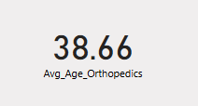

1. **Were there any data format issues in the data, and if there were/are how you handle them?**

#### 1. Date Format Issues

* Split the date column into separate visit_date and visit_time columns.
* Converted visit_date to proper Date format and visit_time to Time format.
* Solution: Used Power Query to convert it explicitly to a proper date type using Change Type ➝ *Date*. Also separated it into Year and Month columns for easier analysis.

#### 2. Null or Missing Values

* Columns like patient_sat_score contained null values.
* Solution:  
  + Replaced nulls values with average score.
  + In some cases, removed rows with critical missing data using Power Query's Remove Rows ➝ Remove Blank Rows.

#### 3. Incorrect Data Types

* Some numeric columns like appointment_fees, patient_age, and wait_time were detected as text (abc format).
* Solution: Converted these columns to proper Whole Number or Decimal Number types using Transform ➝ Data Type.

#### 4. Categorical Columns Treated as Text

Columns like patient_gender, department_referral, and patient_race were correctly recognized as text but used later as categories in visuals.

1. **When we add a column in Power Query what’s the code that comes in M language in the formula bar? What do you know about M-query?**

= Table.AddColumn(#"Previous Step", "New Column Name", each [ColumnA] + [ColumnB])

M is the formula language used in Power Query. It stands for “Mashup” and is a case-sensitive, functional language.

Key points about M:

M is used behind the scenes in Power Query for all data transformation steps.

Each applied step corresponds to a line of M code.

It's immutable: each step creates a new table based on the previous one.

You can manually edit M code in the Advanced Editor for complex operations.

Examples of M functions: Table.AddColumn, Table.RemoveRows, Text.Upper, DateTime.FromText, etc.

1. **Identify the top 5 doctors who generated the most revenue but had the fewest patients. (SQL)**

SELECT

d.Doctor_Name,

COUNT(DISTINCT d.patient_id) AS patient_count,

SUM(d.Total_Bill) AS total_revenue

FROM er_doctor d

GROUP BY d.Doctor_Name

ORDER BY total_revenue DESC, patient_count ASC

LIMIT 5;

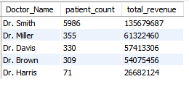

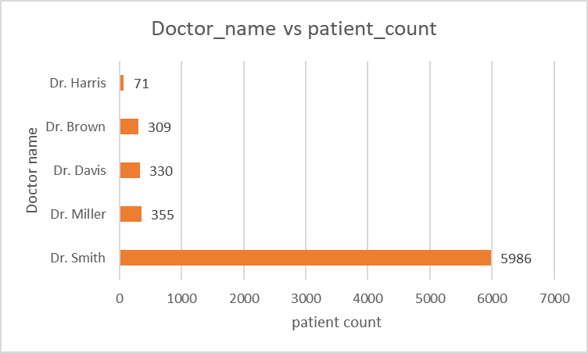

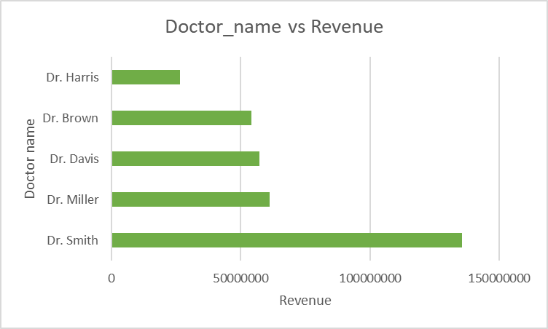

1. **Find the department where the average waiting time has decreased over three consecutive months. (SQL)**

WITH avg_waits AS (

SELECT

department_referral,

YEAR(visit_date) AS yr,

MONTH(visit_date) AS mth,

AVG(patient_waittime) AS avg_wait

FROM er_patients

GROUP BY department_referral, yr, mth),

ordered_waits AS (

SELECT *,

LAG(avg_wait, 1) OVER (PARTITION BY department_referral ORDER BY yr, mth) AS prev1,

LAG(avg_wait, 2) OVER (PARTITION BY department_referral ORDER BY yr, mth) AS prev2

FROM avg_waits)

SELECT DISTINCT department_referral

FROM ordered_waits

WHERE prev2 IS NOT NULL

AND avg_wait < prev1

AND prev1 < prev2;

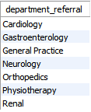

1. **Determine the ratio of male to female patients for each doctor and rank the doctors based on this ratio. (SQL)**

SELECT

d.Doctor_Name,

SUM(CASE WHEN p.patient_gender = 'Male' THEN 1 ELSE 0 END) AS male_count,

SUM(CASE WHEN p.patient_gender = 'Female' THEN 1 ELSE 0 END) AS female_count,

ROUND(1.0 * SUM(CASE WHEN p.patient_gender = 'Male' THEN 1 ELSE 0 END) /

NULLIF(SUM(CASE WHEN p.patient_gender = 'Female' THEN 1 ELSE 0 END), 0), 2) AS male_female_ratio

FROM er_doctor d

JOIN er_patients p ON d.patient_id = p.patient_id

GROUP BY d.Doctor_Name

ORDER BY male_female_ratio DESC;

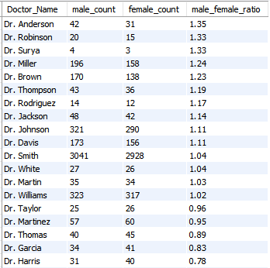

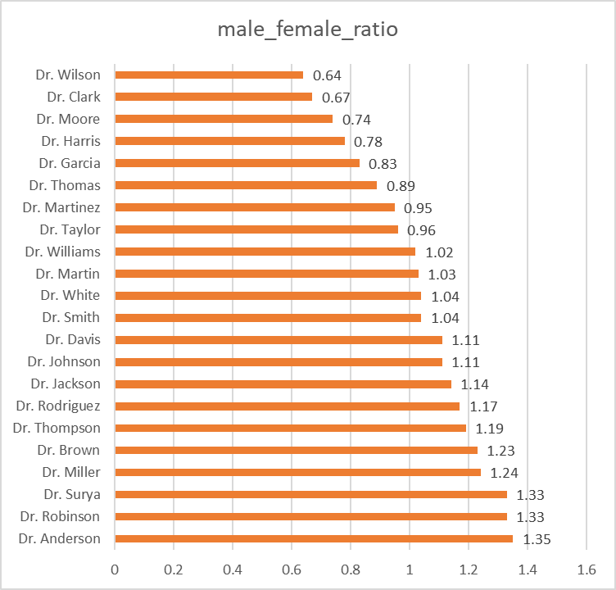

1. **Calculate the average satisfaction score of patients for each doctor based on their visits. (SQL)**

SELECT d.Doctor_Name, ROUND(AVG(p.patient_sat_score), 2) AS avg_satisfaction

FROM er_doctor d

JOIN er_patients p ON d.patient_id = p.patient_id

GROUP BY d.Doctor_Name

ORDER BY avg_satisfaction DESC;

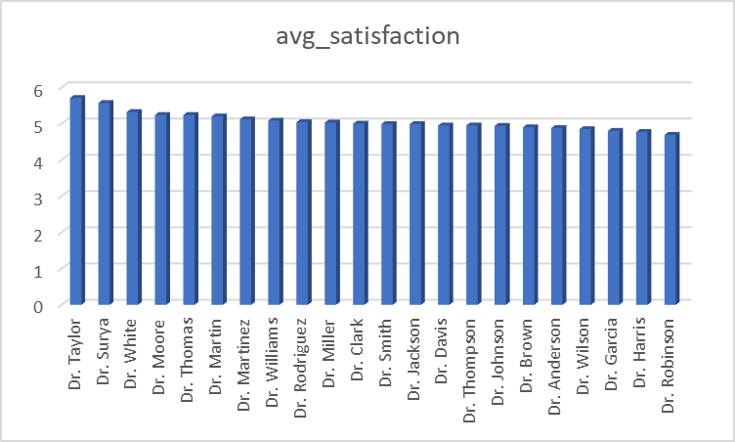

1. **Find doctors who have treated patients from different races and calculate the diversity of their patient base. (SQL)**

SELECT d.Doctor_Name, COUNT(DISTINCT p.patient_race) AS race_diversity

FROM er_doctor d

JOIN er_patients p ON d.patient_id = p.patient_id

GROUP BY d.Doctor_Name

ORDER BY race_diversity DESC;

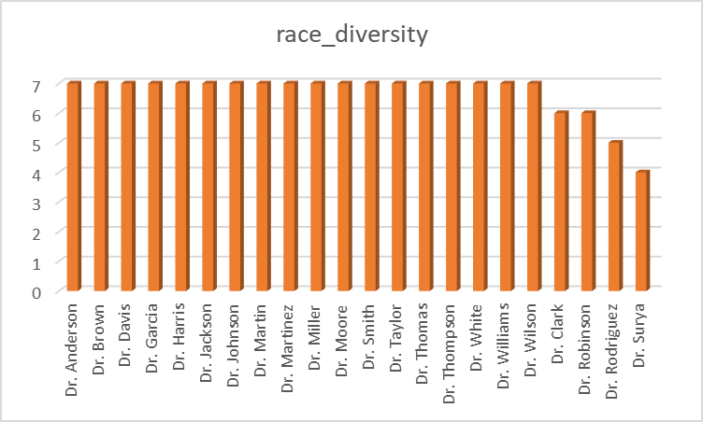

1. **Calculate the ratio of total bills generated by male patients to female patients for each department. (SQL)**

SELECT d.department_referral,

ROUND (SUM(CASE WHEN p.patient_gender = 'Male' THEN d.Total_Bill ELSE 0 END) / NULLIF(SUM(CASE WHEN p.patient_gender = 'Female' THEN d.Total_Bill ELSE 0 END), 0), 2 ) AS male_female_bill_ratio

FROM er_doctor d

JOIN er_patients p ON d.patient_id = p.patient_id

GROUP BY d.department_referral;

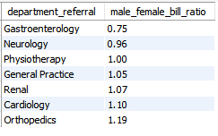

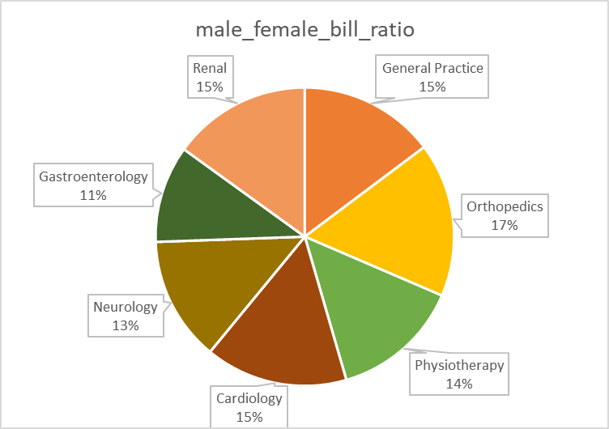

1. **Update the patient satisfaction score for all patients who visited the "General Practice" department and had a waiting time of more than 30 minutes. Increase their satisfaction score by 2 points, but ensure that the satisfaction score does not exceed 10. (SQL)**

UPDATE er_patients

SET patient_sat_score = LEAST(patient_sat_score + 2, 10)

WHERE department_referral = 'General Practice'

AND patient_waittime > 30;

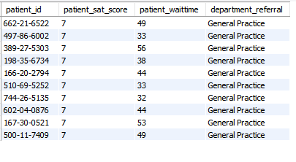

**Subjective Questions**

1. **What is the relation between patient wait time and satisfaction scores?**

**Insight:**

* Average Wait Time: 35.25 minutes
* Average Satisfaction Score: 5.90 out of 10
* Departments like Physiotherapy (36.57 mins) and Neurology (36.8 mins) have lower average satisfaction scores (4.85 and 5.07 respectively).

**Recommendation:**  
There is a negative correlation between wait time and patient satisfaction — departments with longer wait times generally receive lower satisfaction scores.

* Streamline scheduling in departments with longer wait times to enhance satisfaction.

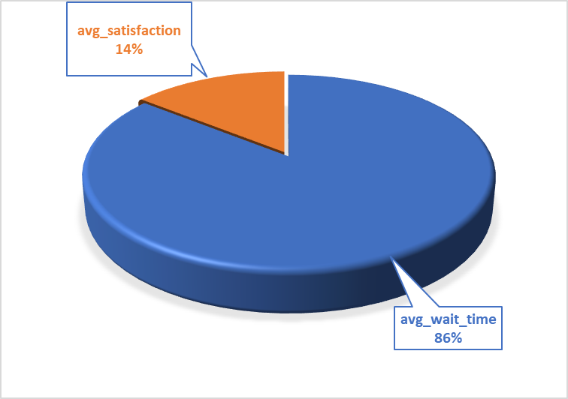

1. **How do patient demographics affect the frequency of visits to different departments?**

**Insight:**

* Middle-aged patients (both genders) have the highest number of visits, especially in General Practice.
* Young Adults also show high visit counts.
* Teenagers and Children have fewer visits overall, especially in Orthopedics.
* Visit frequency is fairly balanced across genders in all age groups and departments.

**Recommendation:**

* Middle-aged and young adults are the hospital’s most frequent visitors, likely due to chronic conditions, checkups, and adult-onset diseases.
* Departments should staff accordingly and tailor services to these age groups.

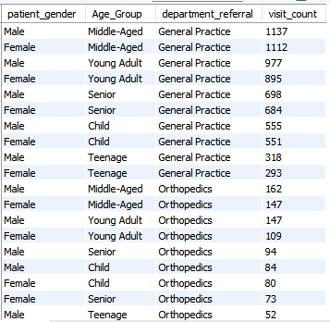

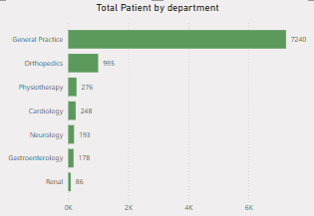



1. **Is there a noticeable trend in the volume of patient visits throughout the year?**

From monthly data (2019–2020):

* Increase in visits from April 2019 (478) to August 2020 (527).
* Slight dips in February 2020 (428) and April 2020 (467) — likely due to COVID-19 lockdown effects.

**Conclusion:**

* There's a general upward trend, suggesting growing patient engagement.
* Seasonal dips align with public health or environmental events (e.g., flu season, pandemic).

**Recommendation:**

* Plan extra staffing for months with higher visits (e.g., May–August).
* Run public health campaigns during low-footfall months to balance load.

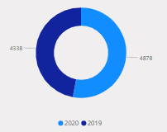

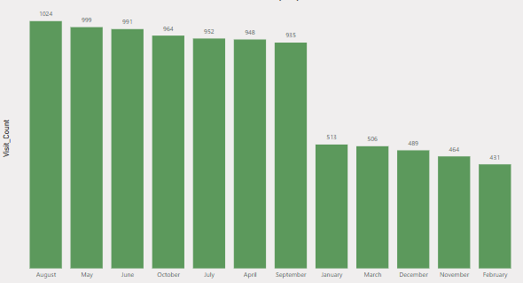

1. **Which age groups report the highest and lowest satisfaction scores?**

**Insight from the data:**

* Highest Satisfaction:
  + Child (5.94), Young Adult (5.92)
* Lowest Satisfaction:
  + Teenage (5.77), Senior (5.87)

**Conclusion:**

* Teenagers are the least satisfied.
* Possibly due to less targeted communication or lack of autonomy in decisions.

**Recommendation:**

* Implement teen-friendly spaces or communication protocols.
* Train staff for more engaging interaction with teens.

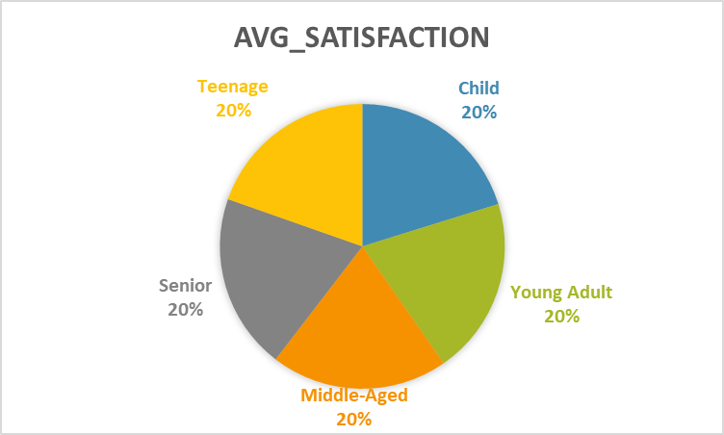

1. **Say someone outside of the hospital claims that there is racial or gender-based discrimination in the hospital, how will you identify whether the claim was right or not?**

**From satisfaction scores by gender and race:**

* General Practice: Very consistent, both genders and races score ~6.1–6.2 → No bias observed.
* Other departments (e.g., Cardiology, Neurology, Orthopedics):  
  + Males generally score lower than females.
  + Some racial groups (e.g., Asian males in Neurology: 4.73, Renal: 3.17) show notably lower scores.

**Approach to validate discrimination claims:**

1. Compare satisfaction across race/gender in the same department.
2. Use statistical testing (e.g., ANOVA) to detect significant bias.
3. Consider other factors: treatment success, complaints filed, and wait times.

**Conclusion:**

* Some patterns suggest potential disparities in certain departments (Renal, Neurology).
* However, differences may arise from sample size, medical complexity, or cultural expectations.

**Action Plan:**

* Initiate internal review in departments with noticeable score differences.
* Conduct anonymous feedback surveys by race/gender.

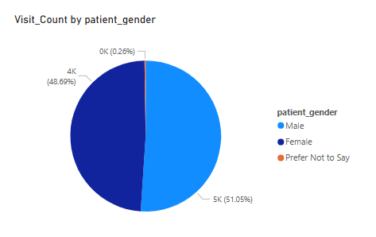

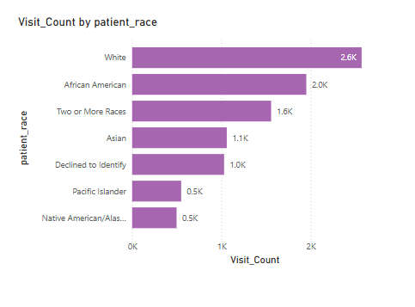

1. **The hospital management intends to offer discounts to patients. How should these offers/discounts be assigned to patients, on what basis, and why?**

Based on the data:

A. Age-Based Discounts:

* Offer discounts to Seniors (60+) and Children (high visit needs or affordability concerns).

B. Visit Frequency-Based:

* Frequent visitors: Middle-aged (1137 visits - Male) and Young Adults.

Offer loyalty rewards or bundled checkup packages.

C. Department-Based:

* High-frequency departments (e.g., General Practice, Orthopedics) can offer:  
  First-visit free, 10% off after 5 visits, etc.

D. Satisfaction Recovery:

Offer discounts to patients with:

* 1. Low satisfaction scores (<5.0)
  2. E.g., teenage and senior patients, or races with lower scores (Asian males in Renal, Neurology).

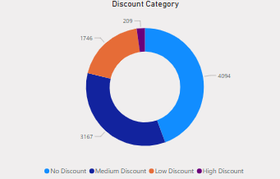

1. **The hospital has a budget to hire 2-3 new doctors. They have asked for your suggestions on which departments they should hire.**

From the data:

* Visit Counts (Top departments):  
  + General Practice: 7220 visits
  + Orthopedics: 992 visits
  + Physiotherapy: 276 visits
* Wait Times:  
  + General Practice: 35.18 minutes
  + Orthopedics: 35.00 minutes
  + Physiotherapy: 36.57 minutes
  + Neurology: 36.80 minutes (highest)

**Suggested Departments to Hire:**

* General Practice → Extremely high patient volume (7220 visits), sustained average wait time. This department clearly needs more capacity.
* Neurology → Has the highest average wait time (36.8 minutes) even though its visit volume isn't listed directly — a sign of understaffing or inefficiency.
* Orthopedics → Moderate patient load and similar wait time. May need support if patient numbers are increasing.

**Recommendation:**

Hire 2 doctors in General Practice, and 1 doctor in Neurology to address the demand and wait time concerns.

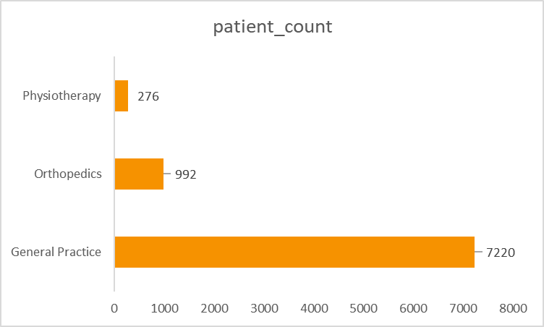

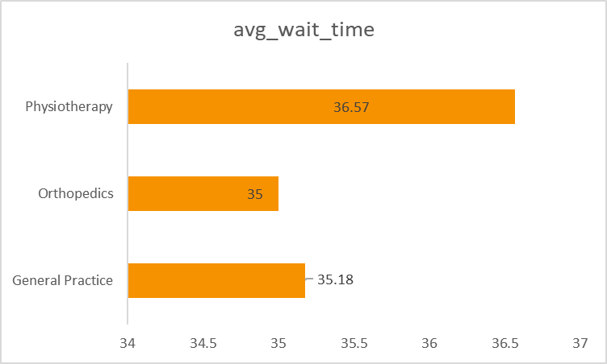

1. **Is the hospital profitable? How will you determine the profitability?**

* Total Revenue: ₹509,309,117
* Total Patients: 9,216
* Revenue per Patient: ₹55,263.58

We can infer profitability only if we know the cost per patient (expenses per visit), but that’s not provided.

However, we can still assess a rough indicator of performance:

* ₹55,263.58 per patient is very high, suggesting revenue is strong.
* With 9,216 patients, the hospital is serving many individuals and earning over ₹50 Cr total.

**Conclusion:**While exact profitability can’t be confirmed without cost data, the high revenue per patient and total revenue suggest the hospital is likely profitable.

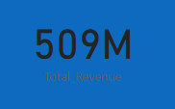 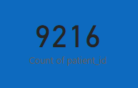

1. **Any Department for which the waiting time is oddly large?**

Yes, Neurology stands out:

* Average Wait Time = 36.8 minutes, the highest among all departments.
* It is not one of the highest-visit departments, which means the wait is not purely due to patient volume.

This indicates potential:

Staff shortage, Inefficiencies, Scheduling bottlenecks.

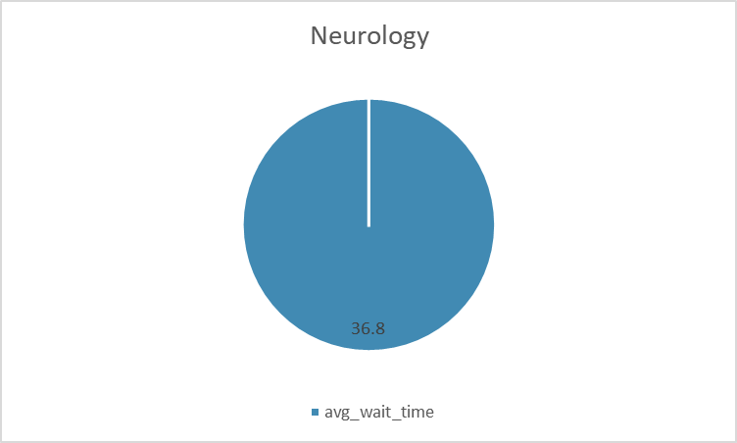

1. **Come up with strategies to provide discounts to the patients.**

### Proposed Discount Strategies:

#### a. Based on Age Group (Encouraging Regular Checkups)

* Senior (60+) and Children (<12) receive 10–15% discounts.  
  Rationale: Seniors and children may have recurring medical needs and lower income.

#### b. Based on Visit Frequency

* Patients visiting 3 or more times in 6 months get Loyalty Discounts (10%) on the 4th visit.
* Encourages follow-ups and continuous care.

#### c. Based on Satisfaction Score

* If a patient rates the hospital ≥8 consistently, offer small thank-you discounts (5–10%) as retention perks.

#### d. For Dissatisfied Patients (Score ≤4 or “HIGH” Dissatisfaction Level)

* Offer them discount coupons or free consultations on the next visit to regain trust.

#### e. Group Discounts / Family Plans

* Offer bundled discounts for families registering multiple patients (like parent + child).

#### f. Demographic-Based Subsidy

* Based on race/gender insights: For example, Native American/Alaska Native and Pacific Islander patients had relatively lower volumes—offering special community-focused discounts can increase inclusivity.

1. **Say you need to align the doctors of the “General Practice” department to work in one of the two shifts, how will you identify what will these two shifts' timings be, and how will you divide the doctors in these two shifts? And also will this 2 shift policy be helpful for the hospital?**

From Dr. Smith’s logs, we can estimate active hospital hours and natural patient inflow patterns:

* Shift A (Morning to Afternoon): 08:00 to 14:00
* Shift B (Afternoon to Evening): 14:00 to 20:00

This covers the peak working hours, and overlaps partially with early/late appointments.

### Divide Doctors into Shifts :

There are 3,535 Female and 3,685 Male patients in General Practice, totaling 7,220 visits.

Assume each doctor can effectively manage about 20 patients per day. If the hospital handles ~240 visits/day (average of 7,220 across a month), you’ll need around 12 doctors in General Practice daily.

Split equally:

* 6 doctors in Shift A
* 6 doctors in Shift B

You can rotate them weekly or monthly to ensure fairness and avoid burnout.

* Reduced Wait Times: More even patient load distribution throughout the day.
* Better Doctor Availability: Extending coverage across hours without overburdening doctors.
* Higher Patient Satisfaction: Flexible scheduling increases convenience for patients.

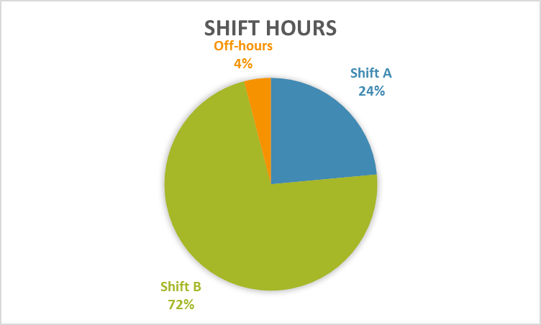

1. **What do you understand by PowerBI gateway? What are its use cases?**

**Power BI Gateway** is a bridge that allows secure data transfer between on-premises data (like Excel files, SQL databases, etc.) and Microsoft Power BI service in the cloud. It enables scheduled refreshes and live queries on datasets hosted locally.

#### **Use Cases:**

* Scheduled Refresh: Automatically update reports with fresh on-prem data (daily/hourly).
* Live/Direct Query: Real-time data access from on-prem sources in dashboards.
* Multiple Microsoft Services: Also connects data for PowerApps, Power Automate, and Azure Logic Apps.
* Data Security: Ensures enterprise-level encryption and access control when transferring data.

1. **How would you approach this problem, if the objective and subjective questions weren't given?**

#### **Step 1: Understand the Dataset**

* Study column names, types (categorical, numerical), and volume of data.
* Identify key entities: Patients, Doctors, Departments, Visits, etc.

#### **Step 2: Formulate Business Questions**

* Operational: Which departments are overloaded? Are wait times affecting satisfaction?
* Demographic: Which age groups visit most? Any trends by gender or race?

#### **Step 3: Data Cleaning & Aggregation**

* Remove duplicates/nulls, correct datatypes.
* Group and aggregate data for KPIs like avg wait time, satisfaction, revenue.

#### **Step 4: Generate Insights**

* Correlation analysis (e.g., wait time vs satisfaction).
* Identify anomalies or outliers (e.g., very low satisfaction for a group).

#### **Step 5: Build Visuals & Recommendations**

* Use line charts, bar graphs, heatmaps.
* Recommend hiring, scheduling, discounts, or system improvements.

1. **Can you analyze and write the type of relationship between the doctor id and department, is it one-to-one?**

* Most doctors are assigned to exactly one department.
* But Doctor CAH022 works in 3 departments.

#### Conclusion:

The relationship between Doctor_ID and Department is One-to-Many (1:N):

* One doctor can be associated with multiple departments.
* One department can also have multiple doctors.

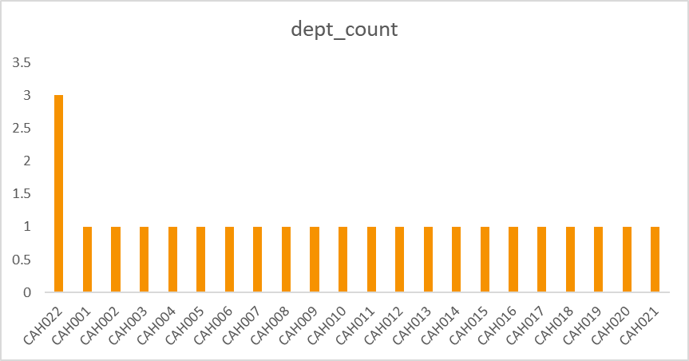

**DASHBOARD**

